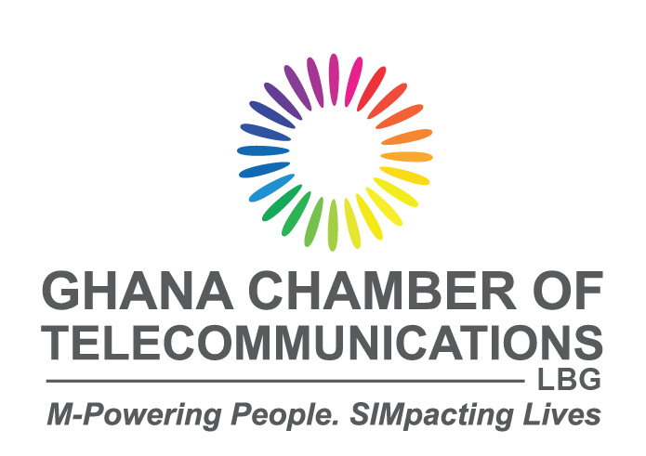 

**Opening Statement Delivered By**

**Dr. Ing. Kenneth Ashigbey - Chairman, Facilitating Committee on the Establishment of the Industry Forum**

**(Chief Executive Officer – Ghana Chamber of Telecommunications & The EMIs Chamber of Ghana)**

**OFFICIAL LAUNCH OF THE INDUSTRY FORUM AND INAUGURATION OF INDEPENDENT ASSESSORS**

**Date: Saturday 20th July, 2024**

**Date:- 22nd October 2024**

**Time: 9:00 am to 1:30 pm**

**Venue: The M.T. Addico Conference Hall Of The Ghana Shippers House, Accra**

**SALUTATIONS**

* Hon. Minister for Communications and Digitalisation, Mrs Ursula Owusu-Ekuful (MP),
* H.E Rosemary Mbabazi, High Commissioner of Rwanda in Ghana
* Dr. Albert Antwi-Boasiako, Director-General, Cyber Security Authority
* Board Members of the Cyber Security Authority
* Members of the Facilitation Committee
* Captains of Industry
* My colleagues from the Media
* Ladies and gentlemen,

**Good morning to you all.**

1. It is a momentous occasion to address you today as we embark on this significant journey to enhance our nation's cybersecurity landscape through the establishment of the Industry Forum, a pivotal step in our cybersecurity strategy as mandated by Section 81 of the Cybersecurity Act 2020 (Act 1038).
2. Yes, Section 81 Act 1038 mandates the Cyber Security Authority (CSA) to establish the industry forum, which is expected to bring together industry stakeholders periodically to discuss matters of common interest. This is consistent with what Prof. Nii Narku Quaynor, The Doyean of Internet in Africa said "***In Africa, the strength of our cyber security lies in our unity and collaborative efforts; together, we can build a resilient digital continent***." -
3. The Authority held a preliminary consultative meeting that outlined the steps and developed a roadmap for establishing the Forum and its official launch. Pursuant to section 81.2, “The ***Authority may designate a body by notice within the industry to be the facilitator for the Forum if the Authority is satisfied*** ***that the body***”.
4. Based on these broad consultations, the CSA formed a 9-member facilitating committee to plan towards the launch of the Industry Forum in October as part of the annual National Cybersecurity Awareness Month (NCSAM) celebrations. Today we are here bringing that to fruition. Thank Dr Albert Antwi-Boasiako.
5. It is essential to recognise and appreciate these nine member organisations and their members ab initio for the great work that they have done.
   1. From the CSA Board
      1. Madam Adelaide Benneh Prempeh
      2. Mr. Carl Sackey
      3. Prof. Boateng Onwona-Agyemang
   2. Mr. John Awuah - _Ghana Association of Banks
   3. International Information System Security Certification Consortium (ISC2)
      1. Mr. Stephen Cudjoe-Seshie -
      2. Mr. Albert Seshie -
   4. From Information Systems Audit and Control Association (ISACA)
      1. Mr. Daniel Gyampo
      2. Mr. Prince Adu
   5. Institute of ICT Professionals Ghana (IIPGH)
      1. Mr. Sherrif Issah
      2. Mr. Emem Umoh
   6. Cyber Security Authority (CSA)
      1. Ms. Eno Brago Attrams
      2. & her colleagues
   7. Dr. Ing. Kenneth Ashigbey - Ghana Chamber of Telecommunications (Chair)
6. The terms of reference given to our committee in May 2024 was for us to
   1. Draw up the Constitution of the Industry Forum (Criteria for membership)
   2. Develop an Industry code pursuant to Section 82 Act 1038
   3. Launch of the Industry Forum in October.
7. In the beginning, it seemed impossible that the constitution and the industry code were going to be completed, and the target was at least to develop a draft at the time of launch. However, the team led by Madam Adelaide Benneh Prempeh and Mr John Awuah, who developed the industry code and constitution, respectively, have been able to deliver both documents, which have undergone some excellent industry critique. All the feedback has been incorporated into the final document. We are grateful to the entire committee and the industry groups that provided their input. A hand of appluse for them.
8. These two documents are living documents, and we plan to workshop them and ensure that the entire ecosystem imbibes them. As we work with them, we refine them further.
9. Our constitution states inter alia that our Forum is established to facilitate collaboration, share knowledge, and promote best practices in cybersecurity across various sectors of the economy. It will discuss the latest trends and threats in cybersecurity and share best practices among industry professionals. The overarching goal of the Forum is to support cybersecurity development in Ghana, enhancing the overall security posture of member organisations by fostering a community of cybersecurity professionals. It currently has six specific purposes.
10. The purpose of the Industry Code, on the other hand, is to;
    1. establish clear ethical and professional standards for all stakeholders in Ghana's cybersecurity ecosystem while promoting compliance awareness of Act 1038 and related regulations.
    2. Provide a voluntary framework to guide the conduct and operations of cybersecurity services and related activities.
    3. Complement the Constitution of the Cybersecurity Industry Forum.
    4. Protect government, businesses, and critical information infrastructure (CII) from the increasing threats of cyberattacks.
11. The chairpersons of the committees that worked on these documents will provide some details during the programme.
12. With the formation of the Industry Forum, we would be able to meet the requirement of section 5.1.c of Act 1038 that states inter alia that ***'The governing body of the Authority is a Board consisting of …¶ three persons from the Industry Forum nominated by the Industry Forum***.' This underscores the significant role the Industry Forum will play in the governance structure of the Cyber Security Authority.
13. I would like to extend my heartfelt appreciation to the Hon. Minister of Communications and Digitalization and the Director-General of the Cyber Security Authority for their visionary support in enabling this pivotal section of the Act and for recognising the nine-member committee as a satisfactory body to facilitate the establishment of this essential Forum.
14. Your commitment to fostering a collaborative environment for industry stakeholders is commendable. It reflects a forward-thinking approach to addressing the complexities of cyber security in our rapidly evolving digital landscape.
15. As we move forward, while acknowledging that both the Minister and the Authority will participate in the Forum as observers, I entreat you both to support our endeavours with the necessary resources. This cooperative framework is vital for establishing a truly independent Industry Forum that can operate effectively and with integrity, ensuring that industry voices are heard and considered in shaping our cyber security policies.
16. Establishing this Forum is not merely a formal exercise; it represents a significant step towards greater regulatory independence for our regulator, which, in turn, will accrue immense benefits to our country as a whole. By fostering a culture of collaboration, transparency, and shared responsibility, we can create an environment where cyber security practices flourish, ultimately enhancing trust and safety in our digital economy.
17. I urge all industry members to dedicate their time and resources to participating actively in this Forum. Your engagement is critical to ensuring that the Forum is vibrant, dynamic, and effective in deepening cybersecurity practices across Ghana. Together, we will support our government and regulator in striving for higher standards and achieving new milestones in our national cyber security framework.
18. To close, I remind all of what Prof. Adnan Aziz, a prominent Cyber Security Specialist, said: "***Cybersecurity is not just a technical challenge; it is a social and economic imperative that requires multi-stakeholder engagement.***" -
19. Let these insights guide us as we foster a collaborative spirit among all stakeholders in cybersecurity. Together, we can elevate our practices and ensure a secure digital future for all Ghanaians.
20. Thank you for your attention.
21. God richly bless our homeland, Ghana, and make our nation great and strong. A nation that does not poison itself, a nation that **StopsGalamseyNow**. We all have a role to play to save ourselves from extinction